**22/23 Gold Member Benefits**

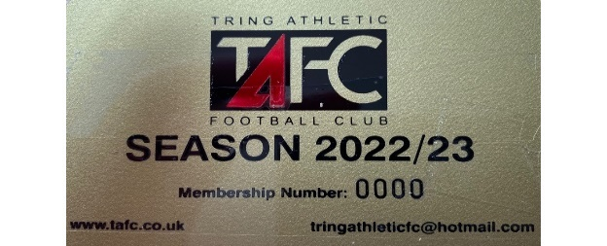

* Free entry to all 1st team home league games
* Free entry to all under 18 youth team home league games in the Allied Counties League
* 20% off at the bar in the clubhouse

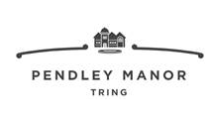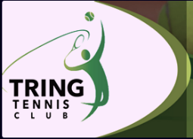

* 15% off Tring Tennis Club new membership fees
* 10% off holiday camps (full course only)
* 10% off Patios and Driveways
* 10% off tennis camps and courses
* 15% off food and beverages
* 10% off Spa treatments
* 15% off food
* 5% discount on fees
* Free initial consultation
* 25% of first year’s fees
* Tax and finance related services
* 10% off fees